Youtube Entity-Relationship Model

Tomás Alejandro Delgado Ortiz

Code: 20221020045

**User Stories**

* As an User, i want to have an interface where i can find my liked and saved videos, suscriptions and playlists in an organized structure, so i can easily move into the content i want to watch
* As a Content Creator User, i want to have the capability to manage my shared videos satitistic data, in retribution of the comments from my suscriptors community, so i can create more accurate content to my community’s requests
* As a User, i want to recieve personalized video recomendations based on my watching history, so that i can discover new content of my interest in the platform
* As an User, i want to be able to create and manage different accounts in the platform, so i can watch different type of content recomendations depending in wich session i´m logged in
* As a Sponsor, i want to be able to check the category, watching statistics and CopyRight category linked to each video, so i can be more accurate promoting my products acording to user needs.
* As a Content Creator User, i want to be able to manage my video´s category and CopyRight Category, so i can create videos in wich the sponsors are interested to monetize

**Entity-Relationship Model Design & Creation:**

1. Component Definition:   
   The components are defined and give context about what you want to model.

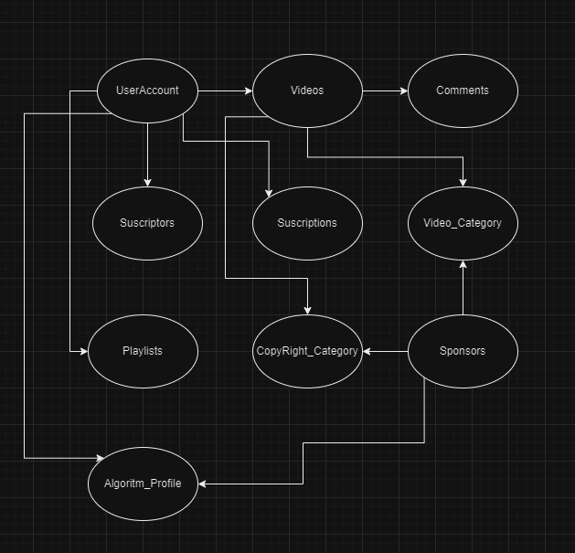

1. Define Entities: Model the actors that establish a relationship with each other according to the context and what was previously defined.
2. Define attributes by entity: being clear about the fields in which intrinsic data is stored according to the context

* E1 UserAccount: nickname, id email, suscriptions, videos, playlists, suscriptors, Algoritm_Profile
* E2 Video:id, name, date, likes, dislikes, category, Coýright_Category, Author, views, Sponsor, comments, playlist
* E3 Comment: autor, likes, dislikes, video
* E4 Suscriptor:id, UserAccount, date
* E5 Suscription: id, User Account, date
* E6 Video_Category: name, videos, likes, dislikes
* E7 Playlists: name, User Account, videos
* E8 Copyright_Category: name, videos
* E9 Sponsors: name, video, producto, Video_Category
* E10: Algoritm_Profile: UserAccount, id, videos

1. Define Relationships between entities according to their functionality within the project

|  |  |  |  |  |  |  |  |  |  |  |
| --- | --- | --- | --- | --- | --- | --- | --- | --- | --- | --- |
| Rel. | E1 | E2 | E3 | E4 | E5 | E6 | E7 | E8 | E9 | E10 |
| E1 | XXX | x |  | x | x |  | x |  |  | x |
| E2 | X | XXX | x |  |  | x | x | x | x | x |
| E3 | x | x | XXX |  |  |  |  |  |  | x |
| E4 | x |  |  | XXX |  |  |  |  |  |  |
| E5 | x |  |  |  | XXX |  |  |  |  |  |
| E6 |  | x |  |  |  | XXX | x |  | x |  |
| E7 | x | x |  |  |  |  | XXX |  |  |  |
| E8 |  | x |  |  |  |  |  | XXX | x |  |
| E9 |  | x |  |  |  |  |  |  | XXX |  |
| E10 | x | x |  |  |  |  |  |  |  | XXX |

1. Define the types of relationships between entities.

* E1 -one to many- E2
* E1 -one to many – E4
* E1 – one to many- E5
* E1 – one to many – E7
* E1 – many to many – E10
* E2 – one to many – E3
* E6 – one to many – E2
* E2 - many to many – E7
* E8 – one to many – E2
* E2 – many to many – E10
* E1 -one to many – E3
* E3 – one to many- E10
* E6 – many to many – E7
* E9 – one to many – E6
* E9 – one to many -E2

**6)** First Entity -Relationship Draw: the relationship is drawn similar to a class diagram, highlighting only the relationships between each entity, evidenced in the previous step.

**7).** Identify primary and foreign keys and use them to break Many - to - many relationships.

*Consideration: To break many-to-many relationships, an intermediate entity is created that will have a many-to-one relationship with each end of the relationship, this entity contains the foreign keys of both entities.*

1. Second Entity-Relationship Draw: a second drawing is made of the relationships between updated entities
2. Create the E-R-M Data Structure, the data with its respective type is indicated for each of the entities and atributes are asigned to each of entity values